1. ReactJS-HOL

1. created myfirstreact project using npx create-react-app command

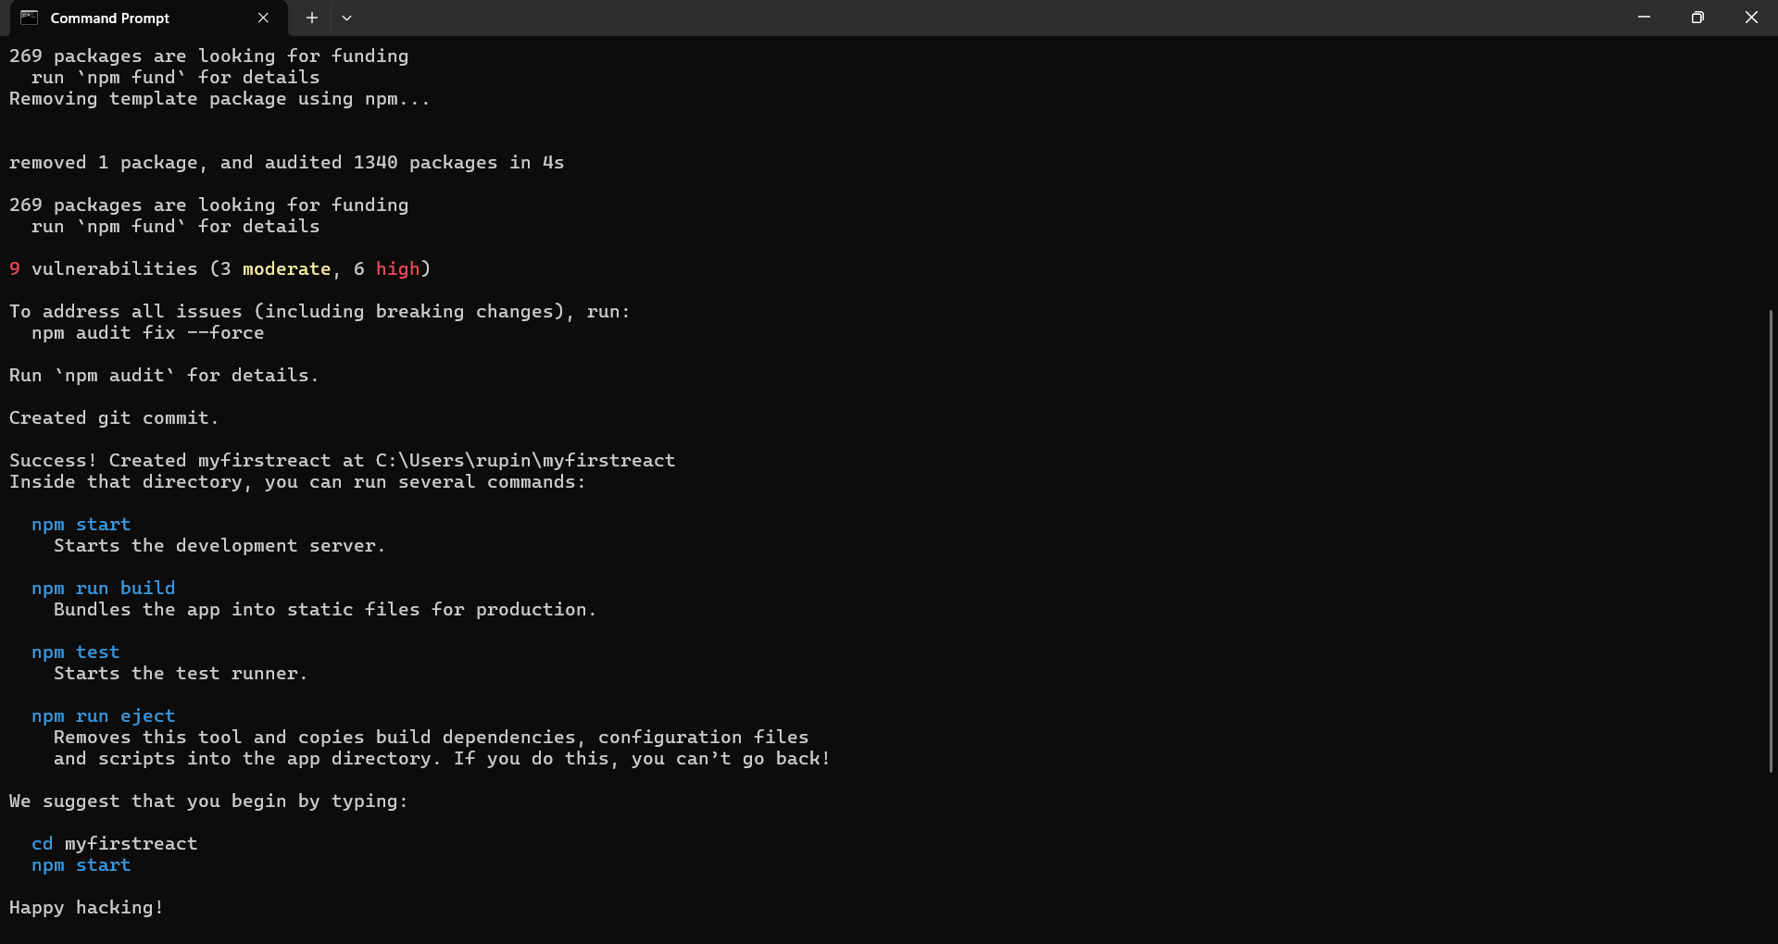

2.imported the project into vs code

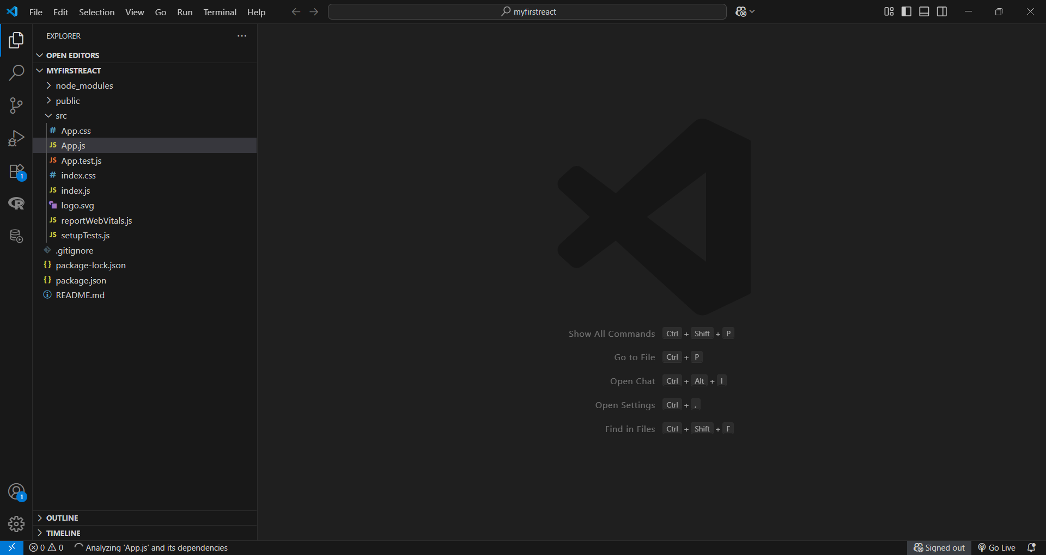

3.modified the content of App.js

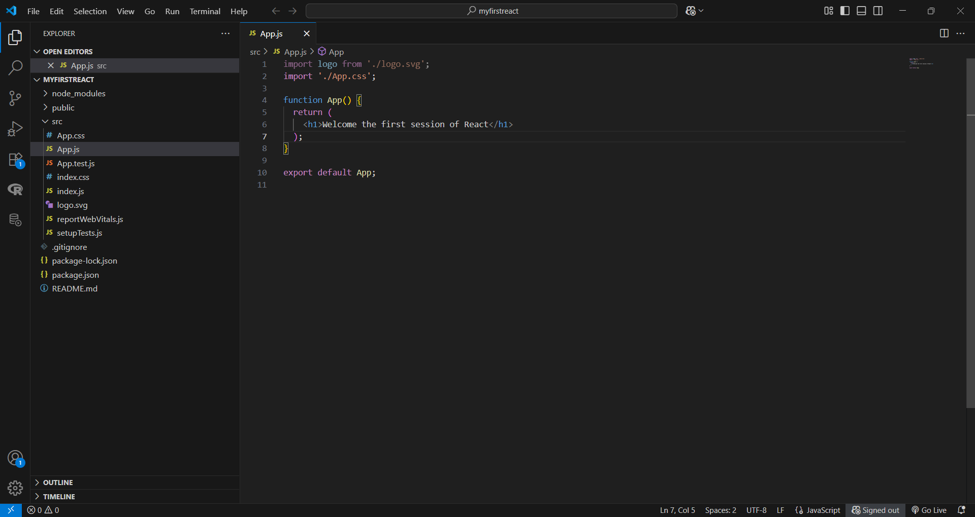

4.executed the react project using npm start command

5.output

